SOLIDARITY 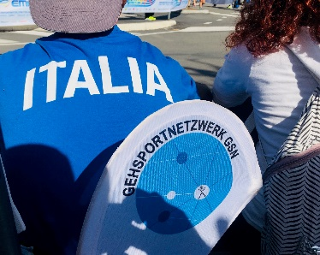 www.gehsportnetzwerk.de
TO OUR FRIENDS FROM THE ITALIAN RACE WALKING TEAM
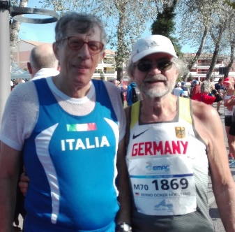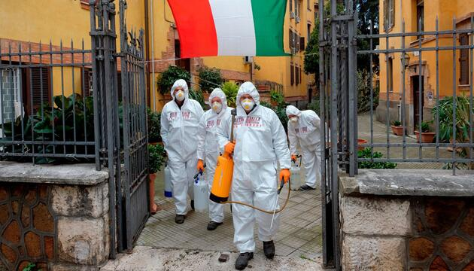
Christoph Höhne often thinks of the hiking friend Piergiorio Andreotti these days
from MC Centro Lazio Roma, age group 75, born 1940. They have been in touch for decades. A few weeks ago, he received a package from him that left him speechless. In addition to souvenirs and two sports T-shorts, including a national team jersey. Hopefully he'll be fine. Bernd handed him a photo album of Christoph at the Masters-EM in Eraclea.

The COVID-19 pandemic has shaken the whole world within a few weeks and is showing dramatic consequences. It has shown us the fragility of our economic and social systems, indeed of human existence.
In Europe, Italy is the country the most affected by the coronavirus: the number of people infected and dead is increasing at an alarming rate every day. Even if the fight against the virus involves restricting our individual and collective freedoms, forcing people to isolate and countries to close borders, no barrier can prevent the spark of solidarity from swelling among us athletes in these difficult times: our thoughts are with you and your families, hoping that you will be spared by the virus. May solidarity also pay off among the citizens of your beautiful country in order to effectively counter the virus. In friendly contact, cordial on soon,
for the walking network: the board of directors Thorsten Fern, Udo Schaeffer, Dick Gnauck, Bernd O. Hölters with the first signatories Christoph Höhne, Otmar Seul,Franz Kropik, Josef Smola, Carl Dohmann, Andreas Janker, Rick Listing, Kathrin Schulze, Steffen Borsch, Peter Schumm, Helga Dräger, Mario Brandt, Diana Obermeyer and other numerous walkers who are friends with us.
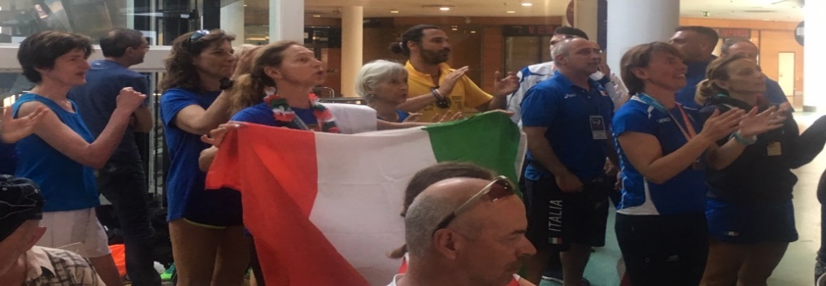
Sunday, March 29, 2020 www.gehsportnetzwerk.de und www.blog.gehsportnetzwerk.de

